Project 1 Submission:

Stephen Drollinger

The running window:

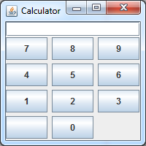

The extra blank button next to the zero is from the Label “”. I wasn’t sure how to handle it, I used all the buttons as a stack and I included that in the stack. My thought is that it may need to be a “+,-,=” buttons so I left it in to show it could be added.

I just read the Q&A for week 4 about the other 2 examples….. I have not accounted for this. I’m submitting what I have because it works off of the original code. I’m sure I could modify the code to accept the other kinds of input. It’ll be easier now that I have a working GUI window with half of the other work done correctly. I would just have to revamp the way I parse in the data. Tomorrow I’ll get you HW4 to you and if I have time changing Project 1.